Protein Folding Activity
Summary
This activity uses manipulation of a prop to understand the type of interactions formed when a protein is undergoing tertiary structure folding and how the properties of amino acids can dictate the final three-dimensional shape of a protein.
Pre activity: pre-reading on protein and amino acids and a short mini-lecture on primary and secondary structure.
Class size: 10-60 students
Materials needed:
- Pipe cleaners
- Different colored tape
Duration: 15-20 min
Type: Manipulation of prop following prompts on screen.
Key concepts: tertiary structure, protein folding, hydrophobic interactions, hydrogen bonds, ionic bonds, disulfide bridges, amino acid structure.
Part 1: Hydrophobic vs Hydrophilic Amino Acids
Assume the green pipe-cleaner represents a polypeptide that has folded into a helical secondary structure and the tape represents the R groups from the amino acids comprising this polypeptide.
Given the key below, predict what the tertiary structure of this polypeptide will be.
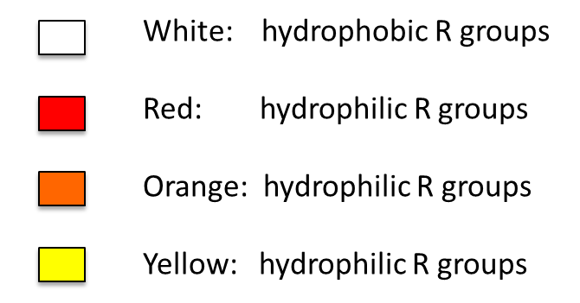

Suggested Answer:
Part 2: Introduction of charged and thiol containing amino acids

Suggested Answer:

Part 3: Follow-up Questions
- What is the type of bond formed between the two orange R groups?
- What is the type of bond formed between the two yellow R groups?
- Using the amino acid table on pg. 53 what is the only possible amino acid that can be represented by the orange tape?
- What possible interactions are occurring between the red R groups and the aqueous environment of the cytoplasm?

